**Special Problem #2 – Ethan Hitchcock - 1408202**

*Introduction*

This problem explored how waves interact with boundaries and the effect of boundaries with different characteristics. A standing wave was generated due to the incident wave being reflected and being superimposed on itself. In some cases, a portion of the wave would also be transmitted through the material instead of being reflected. The following equations were used for perpendicularly polarized incident waves.

Additionally, the following equations were used for parallelly polarized incident waves.

A few more equations were used in the testing for this problem.

Please assume calculations are made using a wave of frequency 50[MHz] with an incidence angle of 30֯ unless otherwise specified.

*Results and Discussion*

1. **Air to a Perfect Conductor**

For a parallelly polarized wave traveling in air and incident on a perfect conductor, it can be assumed that ε2 tends to infinity and thus causes RII to approach 1 and TII to approach 2. This transmitted wave is twice the strength of E­0­ at the surface of the boundary but quickly dissipates due to the infinite conductance of the perfect conductor. Due to testing limitations, very large values were used instead of infinity. Therefore, it is possible to see the decay at the boundary for the H-field. In the ideal case, it would immediately step down to 0[A/m]. This case generated the standing waves shown in figure 1.

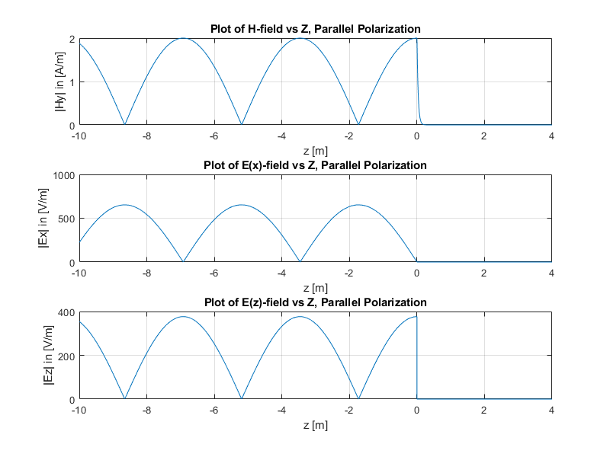*Figure 1: Parallelly Polarized Wave Incident on Perfect Conductor*

It is shown that there can be no electric or magnetic fields within the conducting material itself.

For the perpendicularly polarized case, as ε2 approaches infinity, RI approaches -1 and TI approaches 0. This means the wave is totally reflected and none of the wave is transmitted into the material. The standing waves generated from this situation are shown below in Figure 2. Note, as with the parallel case, electric and magnetic fields are still unable to exist within the perfectly conducting material.

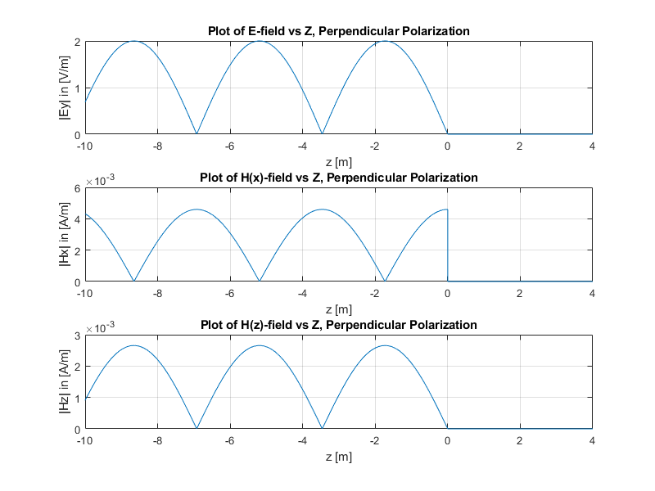*Figure 2: Perpendicularly Polarized Wave Incident on Perfect Conductor*

1. **Air to a Dielectric Material**

For the case where a perpendicularly polarized wave enters a dielectric from air at the boundary, a field is able to exist within the dielectric. If the dielectric is non-conducting, the wave will not be attenuated as it is transmitted through the material. This can be seen in Figure 3.

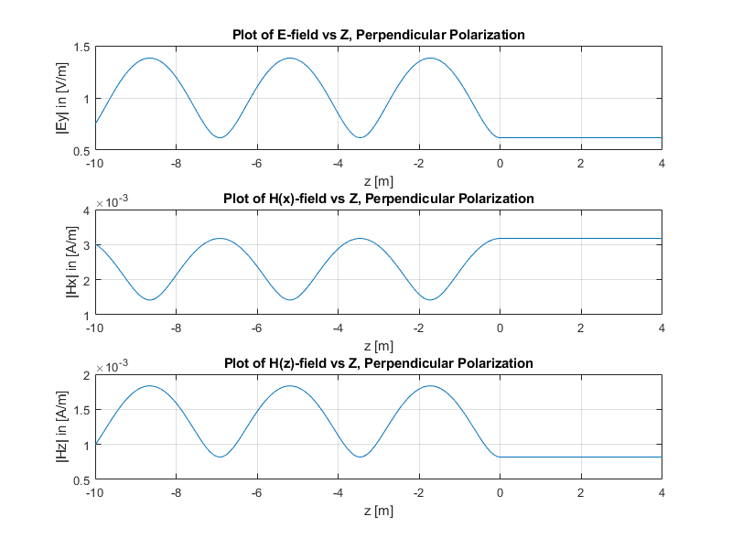*Figure 3: Perpendicularly Polarized Wave Incident on a Dielectric (E­r2 = 4, μr2 = 1)*

For the parallelly polarized wave, the E field in the z-plane follows the rule that EZ1 = EZ2 and consequently ε2 * |EZ2| = ε1 * |EZ1|. This explains the drop in Ez as it encounters the boundary between the mediums. As ε2 is greater than ε1, it follows that |EZ2| < |EZ1|. Figure 4 below depicts the scenario described.

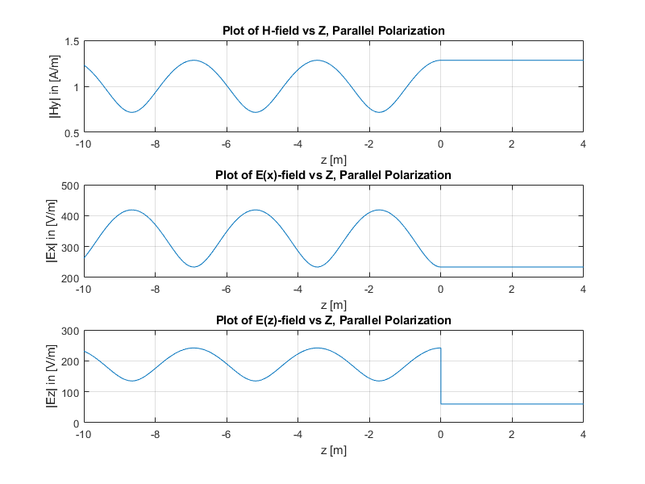*Figure 4: Parallelly Polarized Wave Incident on a Dielectric (E­r2 = 4, μr2 = 1)*

1. **A Dielectric Material to Air – Critical Angle**

The case for a wave travelling through a Dielectric and encountering a boundary with air was dependent on the angle of incidence, θ. When the angle of incidence became greater than the critical angle for the 2 materials, the wave would experience attenuation in the second medium (in this case the second material was air). This is due to ktz becoming imaginary, and thus becoming an attenuation coefficient for the transmitted wave equation. Figure 5 below shows the case where θ < θC and Figure 6 shows the case where θ > θC.

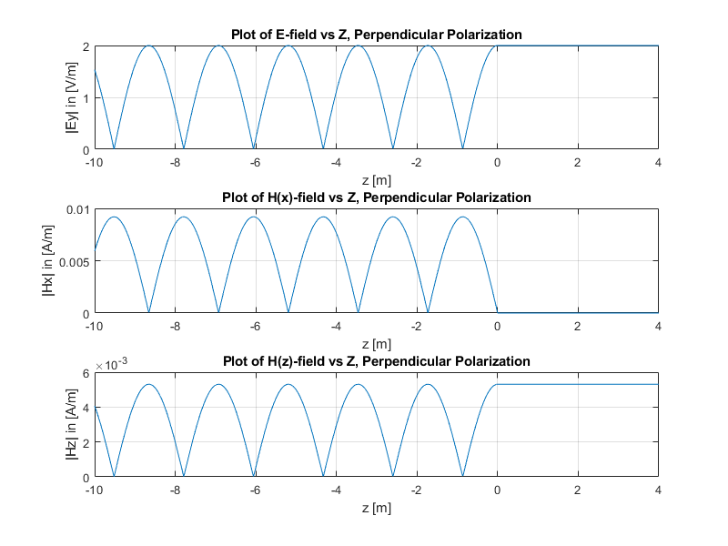*Figure 5: Perpendicularly Polarized Wave Travelling from Dielectric (E­r1 = 4, μr1 = 1) to Air with θ < θC*

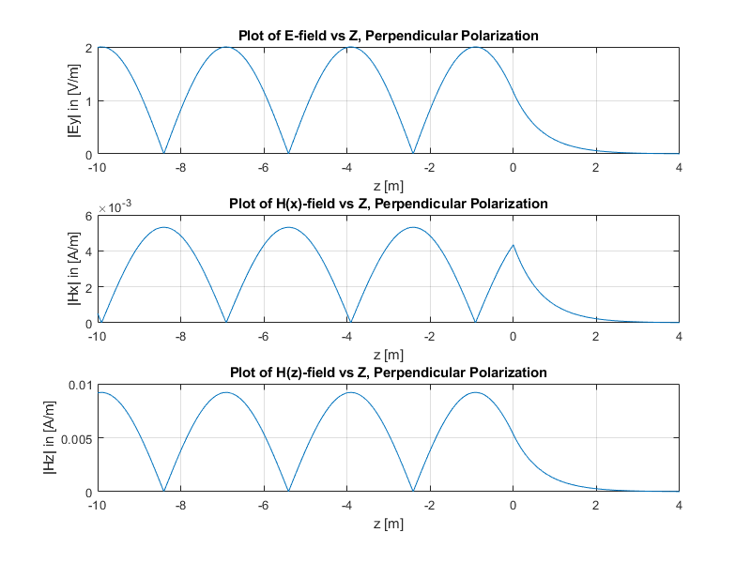 *Figure 6: Perpendicularly Polarized Wave Travelling from Dielectric (E­r1 = 4, μr1 = 1) to Air with θ > θC*

1. **Air to a Dissipative Medium**

In the case where a wave is incident on a dissipative material, the transmitted wave will be dissipated. This is due to the imaginary part of the permittivity constant. A material with a conductivity will result in a permittivity constant with an imaginary part and consequently cause the wave number, ktz, to also have an imaginary part. This will result in an attenuating constant for the wave travelling in the second medium. Figure 7 shows the described scenario in simulation.

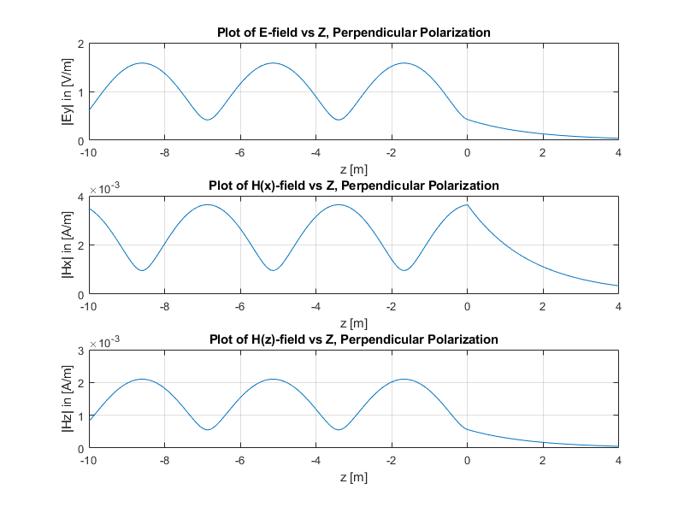*Figure 7: Perpendicularly Polarized Wave Incident on a Dissipating Material (εr2 = 10, μr2 = 1, σ2 = 0.01[S/m])*

1. **Brewster Angle**

At a certain angle for parallel polarization, the entire wave will be transmitted and none of it will be reflected. This is termed the Brewster Angle. This simulation is shown below in Figure 8. Note that the step down at the boundary for E(z) is due to εr1 being 1 and εr2 being 4. This follows the discussion earlier in the case for Air to a Dielectric Material regarding Ez1 being equivalent to EZ2.

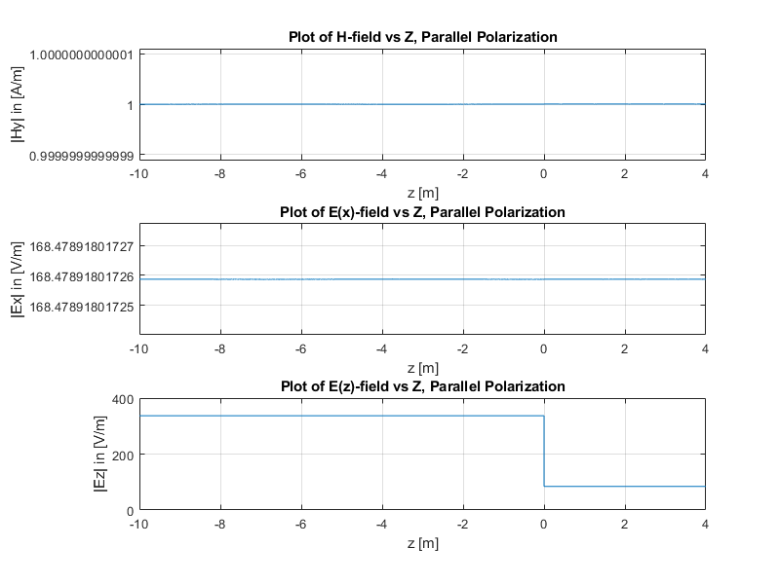*Figure 8: Parallelly Polarized Wave Incident at Brewster Angle (εr2 = 4, μr2 = 1)*

1. **Skin Effect**

This Skin effect describes the tendency of current to flow at the surface of the conductor as opposed to evenly throughout the conductor. Figure 9 depicts the decrease in current density resulting from the dissipating E-field in the second material. The E-field dissipates as it travels further into the second material, consequently the current density also decreases as the distance from the surface or boundary increases.

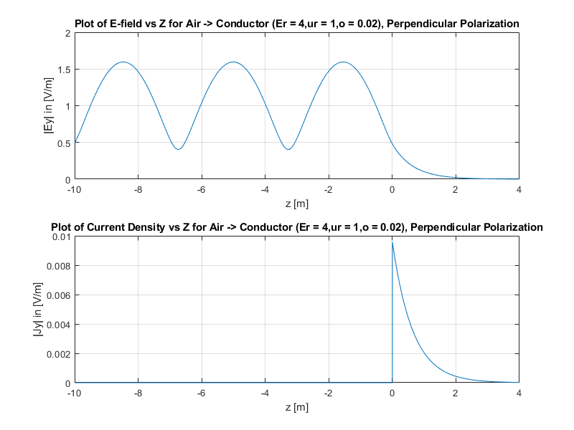*Figure 9: The Skin Effect for a Conducting Material*

1. **Evanescent Waves**

An evanescent wave is one in which no real power is dissipated despite the wave attenuating. This is dependent on whether the wave frequency is less than the plasma frequency of the medium. If the wave frequency is less than the plasma frequency, then the wave number will be imaginary. This results in an attenuating transmitted wave. Figure 10 below shows the scenario described prior.

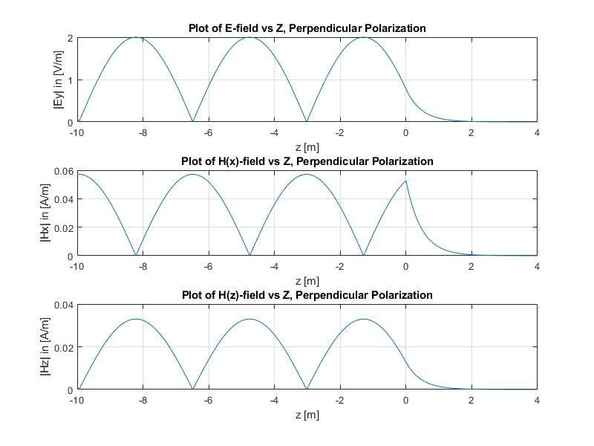*Figure 10: Evanescent Wave Attenuation due to Imaginary Wave Number*

*Conclusion*

The transmission and reflection of an electromagnetic wave at a boundary is dependent on not only the relative permittivity and permeability of the materials, but also on the conductivity of the materials, and the angle of incidence. Not all of these variables is important in every case, but specific interactions between certain mediums can result in the need to monitor different variables to fully conceptualize the scenario being depicted by the graphs simulated.